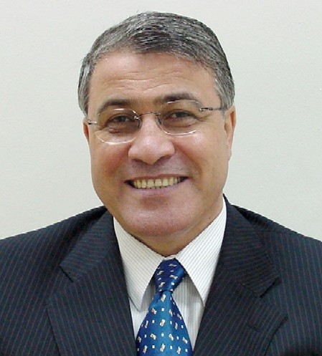

Professor El-Sayed M. El-Horbaty received his Ph.D. (1985) in Computer science from London University, U.K., his M.Sc. (1978) and B.Sc. (1974) in Mathematics from Ain Shams University, Egypt.
His work experience includes 41 years as an academic in Egypt (Ain Shams University), Qatar (Qatar University), and Emirates (Emirates University, Ajman University, and ADU University). He Worked as Deputy Dean of the faculty of IT, Ajman University (2002-2008). He worked as a Vice Dean of the faculty of Computer & Information Sciences, Ain Shams University (2009-2011). He is working as Head of Computer Science Department, in faculty of Computer & Information Sciences, Ain Shams University (2012-2015).
Prof. El-Horbaty’s current areas of research are distributed and parallel computing, Cloud Computing, Image processing, e-health Computing, and Optimization of Computing Algorithms.
His work appeared in many journals such as: Parallel Computing, International Journal of High performance and Grid Computing, International Journal of Information Security, International Journal of Computer Communication and Information Security and International Review on Computers and Software.

