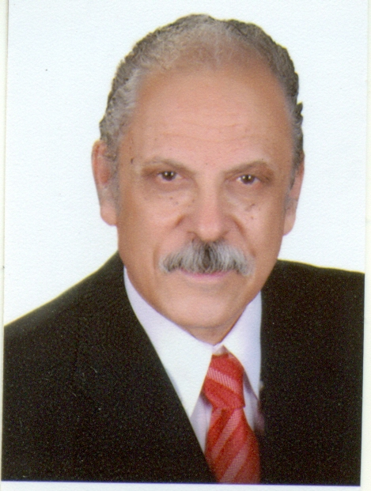
Short CV : Prof. Dr. Abdel-Badeh Mohamed Salem

Prof. Dr. Abdel-Badeh M. Salem is a professor emeritus of Computer Science since September 2007 till now. He was a former Vice Dean of the Faculty of Computer and Information Sciences at Ain Shams University, Cairo-Egypt (1996-2007). He was a full professor Dr.of Computer Science at Faculty of Science, Ain Shams University from 1989 to 1996. He was a Director of Scientific Computing Center at Ain Shams University (1984-1990).In 1996 he was moved to the Faculty of Computer and Information Sciences at the same university. His research includes Knowledge engineering and computing, expert systems, intelligent medical and health informatics, and intelligent e-learning technologies. He has published around 350 papers in refereed journals and conference proceedings in these areas. He has been involved in more than 400 conferences and workshops as a Keynote speaker, member of Int. Program Committees, organizer and Session Chair. He is author and co-author of 20 Books in English and Arabic Languages.
He was one of the founders of the following events, First Egyptian Workshop on Expert Systems 1987, Int. Cairo Conference on Artificial Intelligence Applications in 1992 and Int. Conf. on Intelligent Computing and Information Systems 2002, and one of the main sustainers of annual Int. Romanian Internet Learning Workshop Project (RILW), 1997. In addition he was Secretary of Egyptian Computer Society (1984-1990), Member of National Committee in Informatics – Academy of Scientific Research and Technology (1992-200), Member of Egyptian Committee in the Inter-Governmental Informatics Program, IIP-UNISCO, Paris (1988-1990) and Coordinator of the Annual International Conference for Statistics, Scientific Computing, and Social and Demographic Research (1983-1990). In addition he was a partner of a MEDCAMPUS Projects on Methodologies and Technologies for Distance Education in Mediterranean (1993-1995)
He is a member of the Editorial Board of the following Journals: Int. Journal of Computing and Information Sciences(IJCIS), Canada; Egyptian Computer Science Journal, EC Newsletter, Education in Computing and Computers in Education, Italy; Scientific Journal of Studia Universitatis Babes-Bolyai, Series Informatica, Cluj – Napoca, Romania; International Journal of intelligent computing in medical sciences and image processing (IC-MED), Japan; Egyptian Journal for Specialized Studies, Faculty of Specific Education,Ain Shams University,Egypt; Int. Journal of Intelligent Computing & Information Science”,IJICIS, Egypt; Enformatika Transactions on Engineering, Computing and Technology, World Enformatika Society, Turkey; and Int. Journal of Soft Computing Approaches (IJSCA), Eurojournals.
He is a member of Int. Scientific Societies: American Association of Artificial Intelligence (AAAI), USA; British Computer Society, Expert Systems Specialist Group (SGES), Int. Neural Network Society (INNS), USA; Association for the Advancement of Computing Education (AACE), USA; Int. Society for Computers and their Applications ((ISCA), NC, USA, Dec. 95); Int. Society for Telemedicine & eHealth ISfTeH,, Switzerland; Member of Int. Federation for Information Processing (IFIP) Technical Committee WG 12.5, Knowledge-Oriented Development of Applications, Austria (2000 till now), Member of Int. Association for Science and Technology for Development (IASTED), TC on AI and Expert Systems, Int. Association for Science and Technology for Development, Canada, (2000 till now). Elected member of Euro Mediterranean Academy of Arts and Sciences (EMAAS), September 25, 2015 ,Athens, Greece http://www.euromediterraneanacademy.org/

