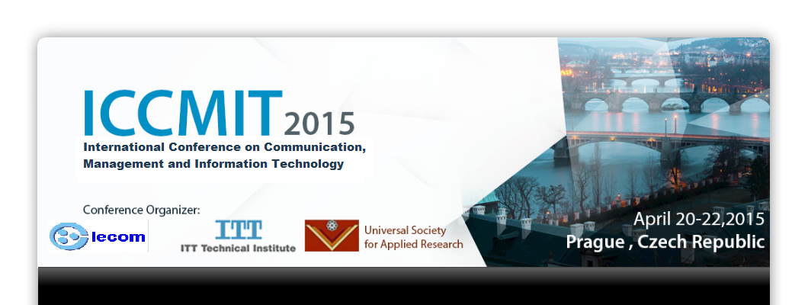
REGISTRATION FORM

First Name: ___________________________ Last Name____________________
University/Organization: _________________________________________________________________________________
Mailing address _________________________________________________________________________________
City: ________________________________ State/Province: ______________________
Zip/Postal Code: _________________Country: _____________________________
Telephone: (______) ________________ Fax: (______) ____________________
Email: __________________________________________________________________
CONFERENCE FEES
- Registration Fees (All fees listed in Euro currency) paper's author and attendant will enjoy 2 lunches, 2 breaks, 2 dinners, sight-seeing trip-, and publication of the paper at journal Procedia Computer Science of Elsevier. While one workshop attendant will enjoy one break and one lunch/or dinner.

Please check appropriate registration fee: before/on March 15 AFTER MARCH 15
Paper's author €450 €500
Two papers author €650 €700
Attendant €300 €350
One Workshop attendant €100 €120

- Indicate tour interest:

A tour (Navigational Cruise) on river "Vltava" will be arranged a round Prague with lunch or dinner on a steam ship or big boat.
A tour to a very beautiful city "Karlovy-vary" will be arranged by bus including a lunch.

- Guest Lunches indicate number of guests for each day: €25 for each guest:
Write full name of guest(s):
………………………………………………………………………………………………………………………………………..
……………………………………………………………………………………………………………………………………….

- Hotel reservation at Hotel Sports: Are you interested to stay at hotel sports, please indicate for how many days ----------------------

Single room €40 for one day
Double room for each person €30 for one day

Cancellations/Changes and Refunds: Fees for missed meals, late arrivals, and early departures will not be refunded. No fees will be refunded after March 5th, less a €30 processing fee, if cancellation or change resulting in a refund is received in writing no later than Feb. 25, 2015. After that date, fees are non-refundable. All refunds will be processed after the conference. Substitutions are allowed at no charge.

PAYMENT METHOD: Fees will be made only through bank transfer to Universal Society for Applied Research. The fees amount should be paid completely and the transfer fees should be paid exclusive of conference fees. A copy of remittance should be said sent to editor@iccmit.net. Payment should be transferred to the following account:
Bank Name: Raiffesien Bank
Bank Address: Jalta, Voaclaske nam, 819/43, 11000, Praha 1, Prague, Czech.
Account Name: Universal Society for Applied Research
Account No. : 4067871001/5500
Swift Code: RZBCCZPP
IBAN: CZ3155000000004067871001

Please mail a completed registration form with payment to:
Conference Registration Chair
Email: editor@iccmit.net

Remark:
Visas are generally required when entering Czech Republic. Participants of ICCMIT 2015 must hold visa for conference purpose. Therefore, please let us know in the registration form whether you will need a visa.

